**Appendix E – UML Diagrams**

**Class Diagrams**

*Camera Object*

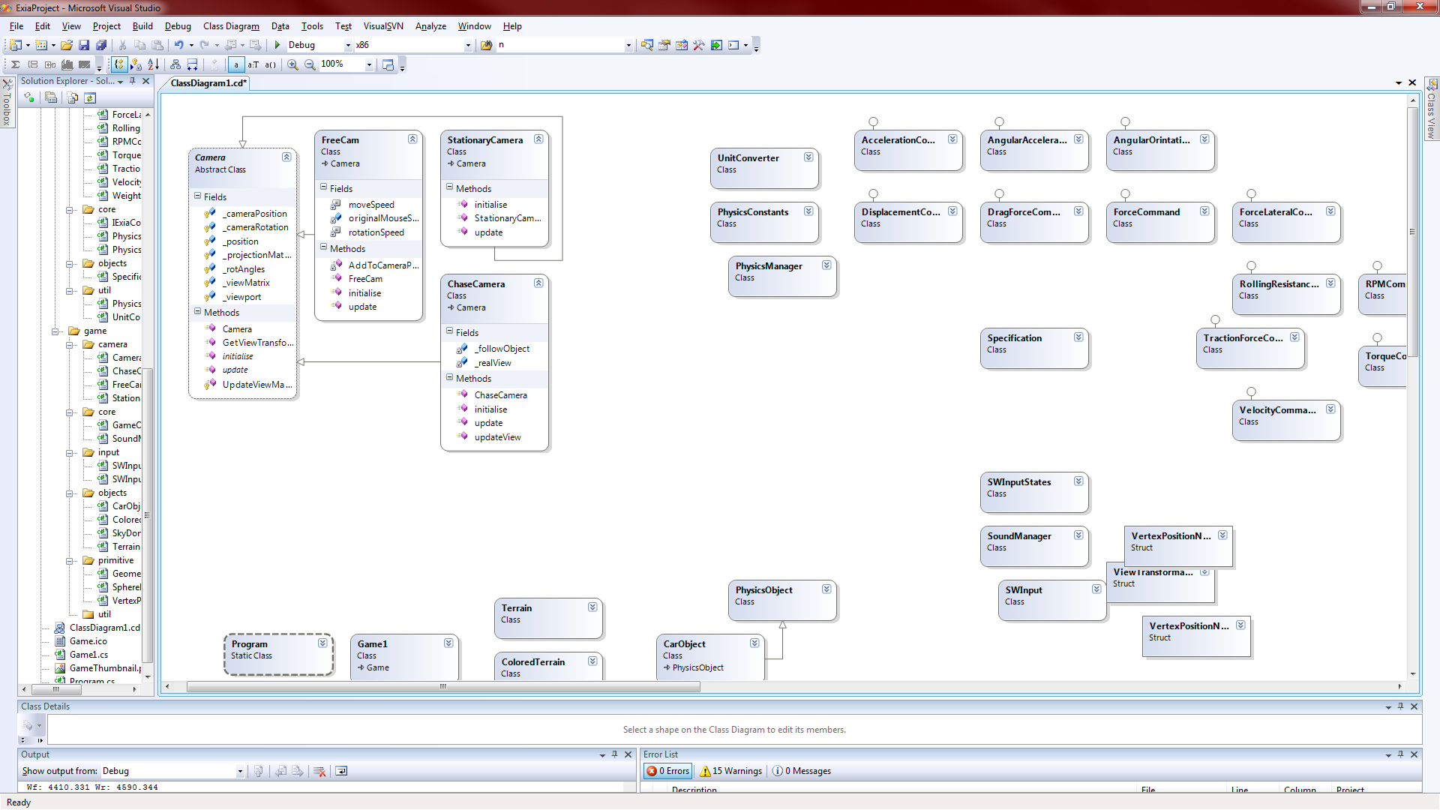

*SkyDome, Terrain & Coloured Terrain Objects*

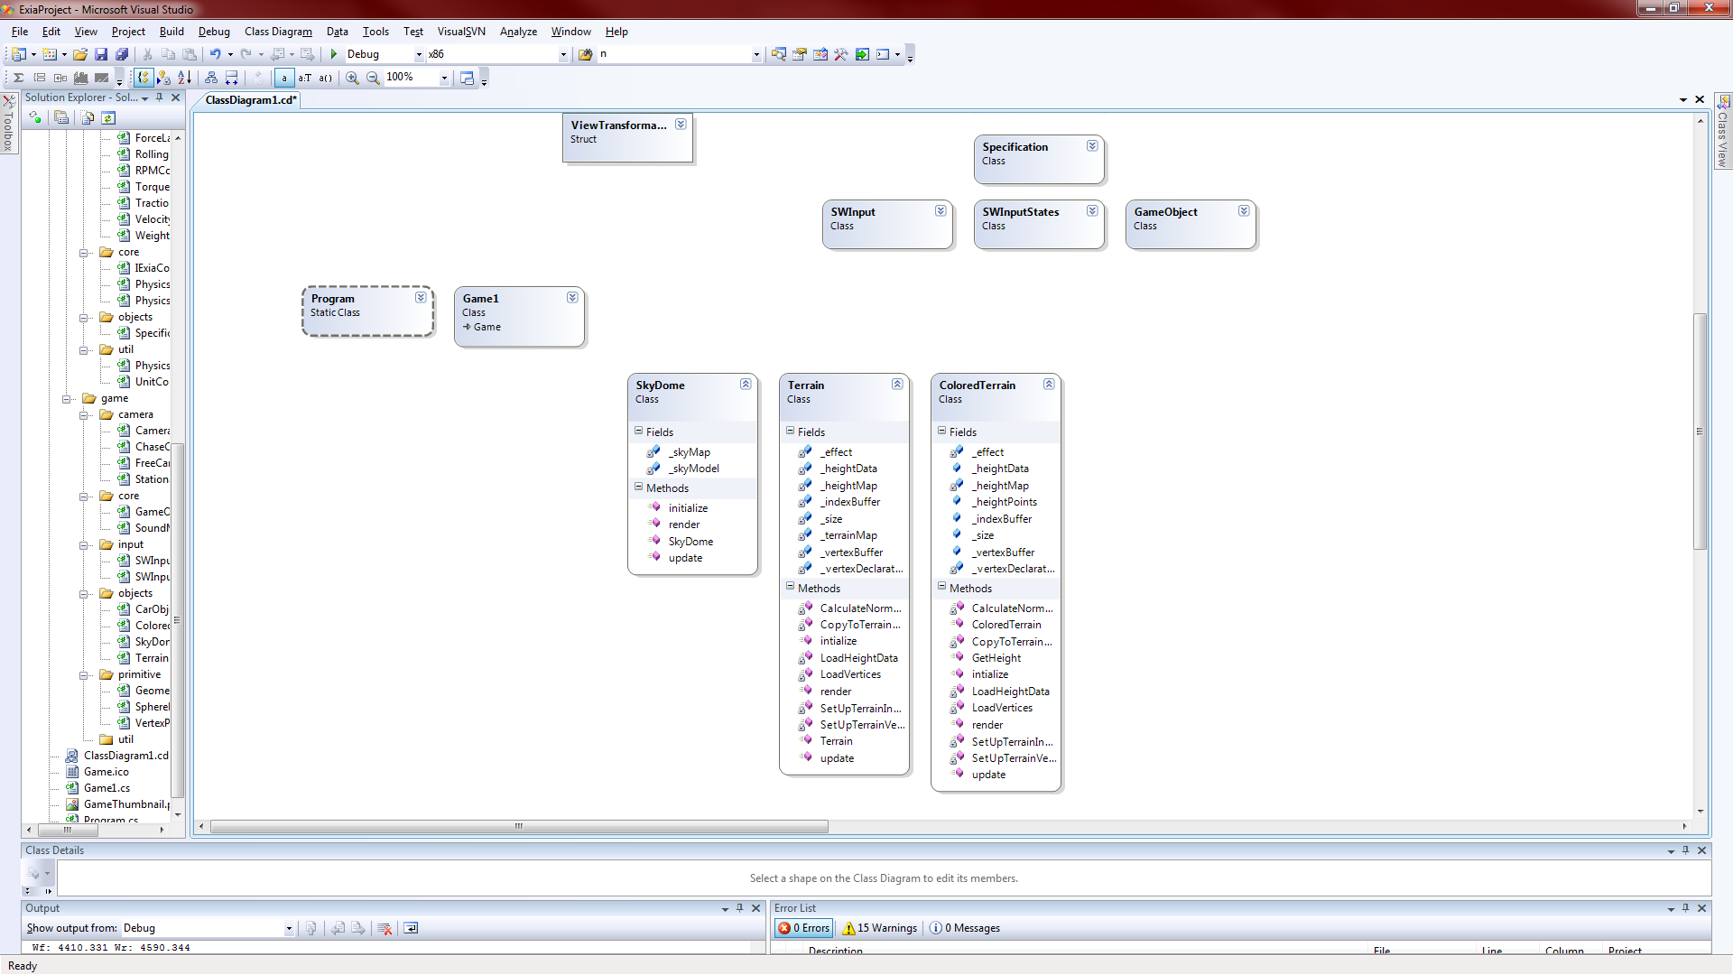

*Structures*

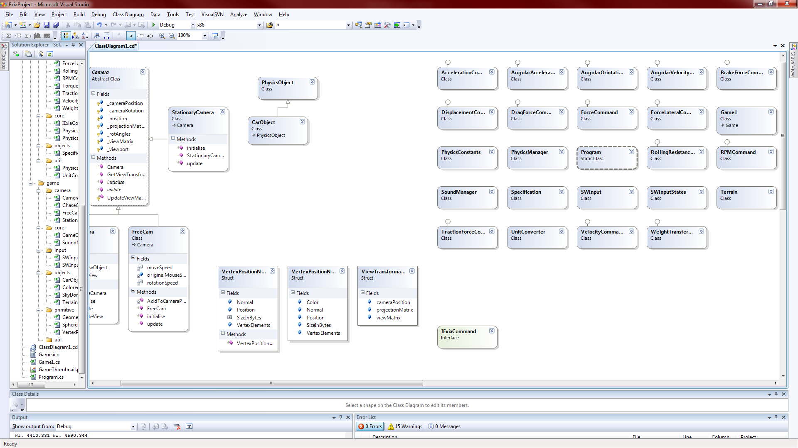

*Car, Physics & Specification Objects*

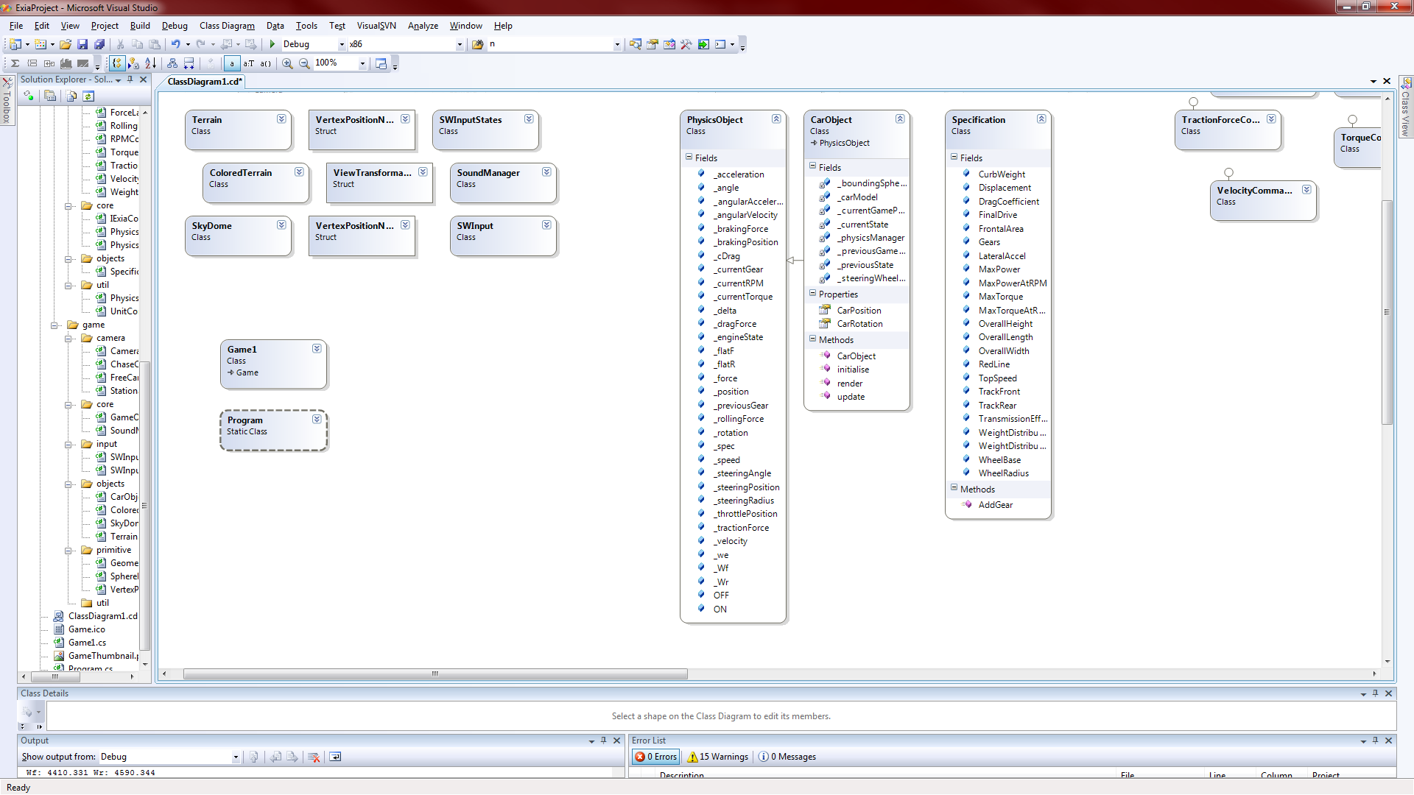

*SWInput, SWInputState and SoundManager Classes*

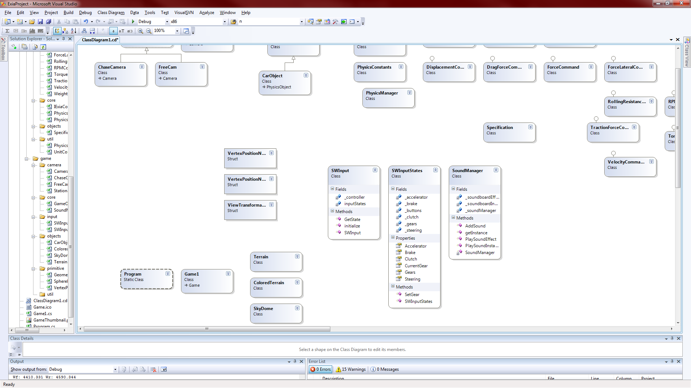

*Physics Manager, Unit Converter & Physics Constant classes*

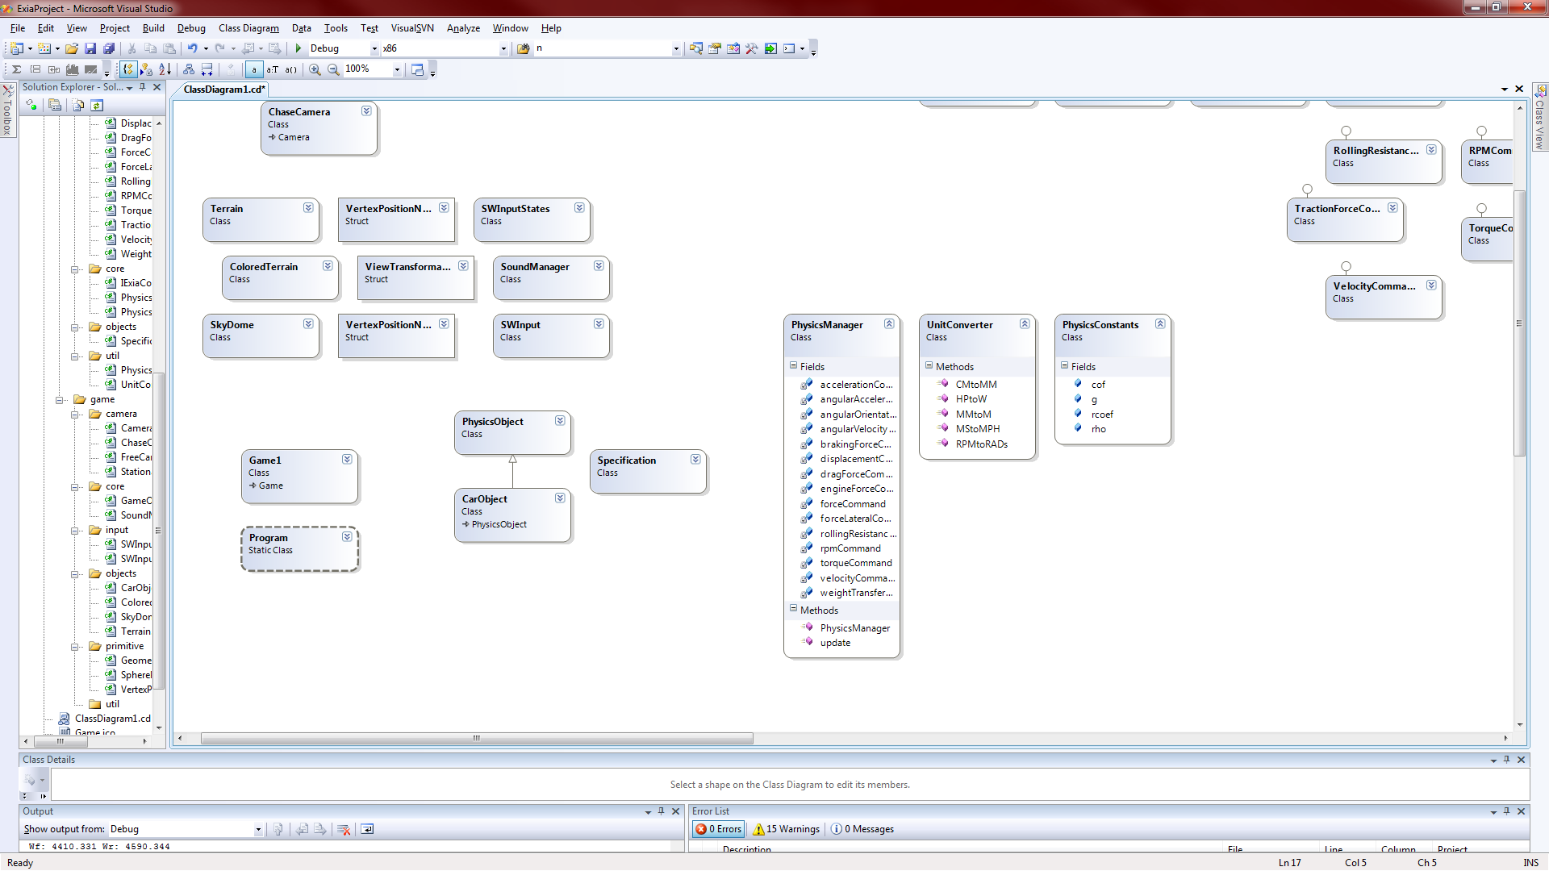

*The Exia Commands*

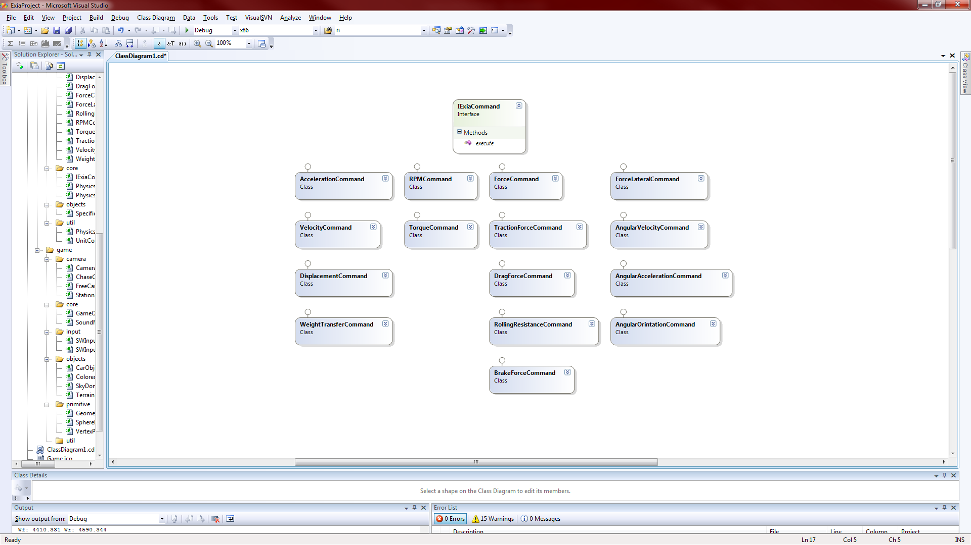

**Sequence Diagram**

